User enters log in information:

Invalid login scenario:



**Valid Employee Log in**

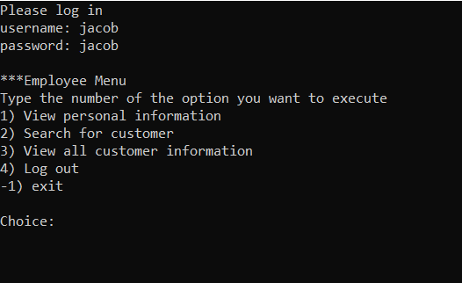

The employee can choose any of the listed options.

Option 1: View personal information

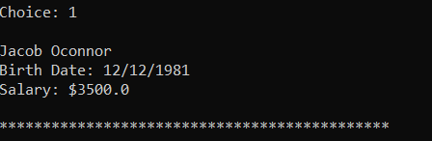

Option 2: Search for customer

First attempt was an invalid customer name, and the error message “Customer not found” is displayed.

The second attempt shows the information of the customer “Marshal Mather”.

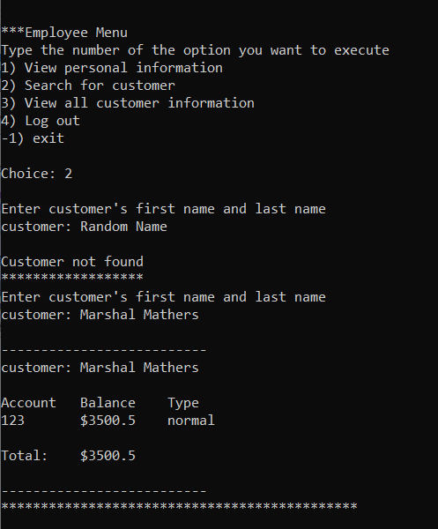

Option 3: View all customer information

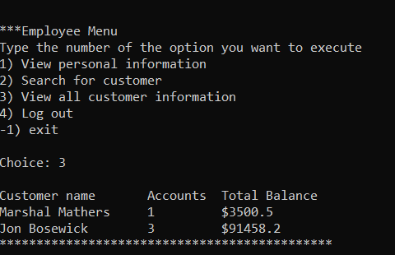

Option 4: Log out

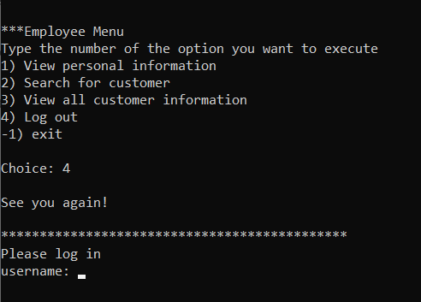

Option -1: exit

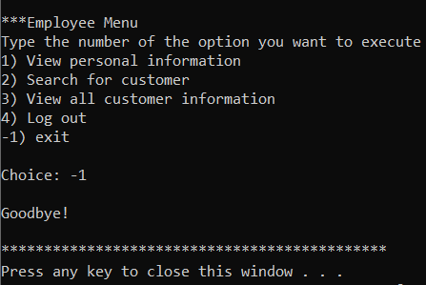

**Valid customer login**

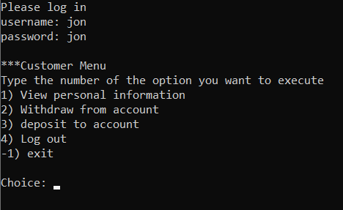

Option 1: View personal information

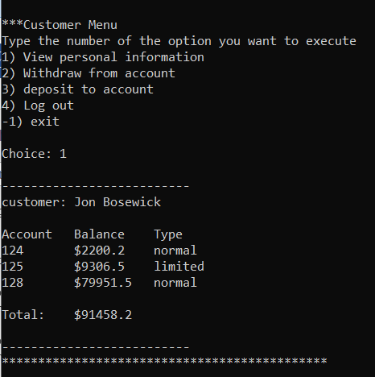

Option 2: Withdraw from account

First attempt on entering an invalid account number gave a warning requesting another account number.

Withdraw of $201 dollars from the limited bank account ‘125’ resulted in a failed transaction (limited accounts have a limit of $200 per transaction.

Invalid

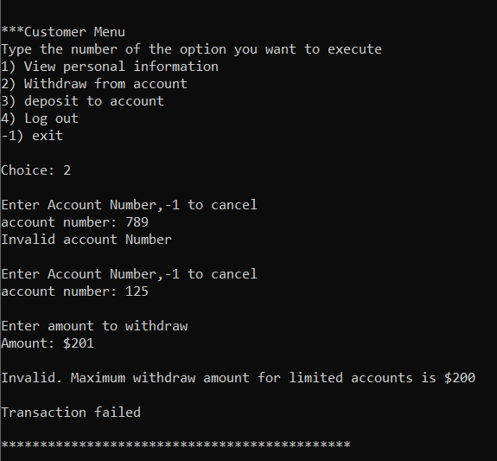

Valid

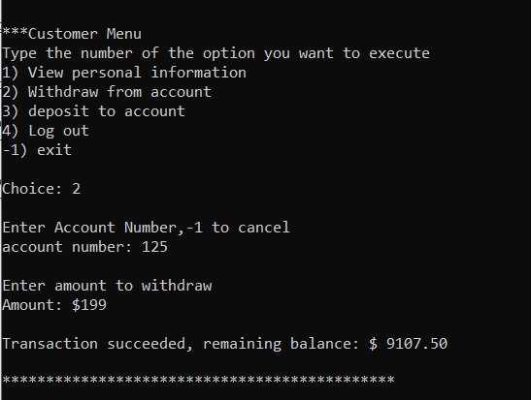

Option 3: Deposit to account

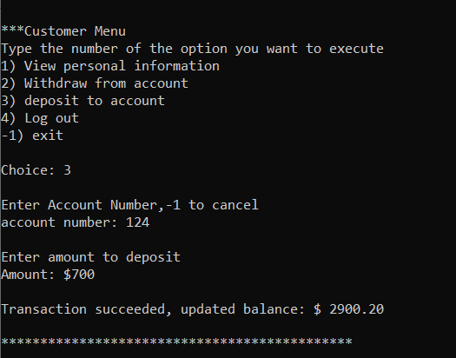

Option 1 again to view the balance changes

